Student Name：Owen Wu
School： Portola High School
State： California
Country： United States of America
Instructor Name：[INSTRUCTOR NAME]
Instructor Affiliation：[INSTRUCTOR AFFILIATION]
Title： [TITLE - TO BE DECIDED]
[TITLE - TO BE DECIDED]
Owen Wu
Abstract
The growing use of speech systems in consequential decisions, including hiring screens, loan applications, and clinical triage, means such systems demand fairness. Yet fairness is usually reported from a single training run, leaving the seed-to-seed variance of the fairness metric itself unmeasured. This paper presents a 50-seed evaluation of trustworthy-intent classification from voice on the Trustworthy Intent in Speech (TIS) Corpus of 1,152 utterances from 96 White, Black, and South Asian speakers. Five classifiers are retrained under 50 random seeds on a fixed joint-stratified 80/20 partition: Random Forest and Logistic Regression baselines from the source study, a feedforward network (ANN), a one-dimensional convolutional network (CNN), and DANN-Trust, which penalizes ethnicity-predictive information in the shared representation through a gradient reversal layer. The maximum-minus-minimum per-ethnicity accuracy gap Δ_eth falls from 12.29 percentage points (pp) under Random Forest to 5.78 pp under the CNN and 6.34 pp under DANN-Trust, indicating that much of the disparity is attributable to the model class rather than to the corpus. Pairwise Mann-Whitney U tests over 50 seeds confirm that CNN and DANN-Trust are statistically indistinguishable on accuracy (p=0.86), ethnicity gap (p=0.26), and sex gap (p=0.73); they are also indistinguishable on the stability of these metrics (Levene's p>0.30 for every pairing). An ablation on the DANN encoder further shows that removing BatchNormalization is required for the adversarial signal to help (accuracy p=0.002, gap mean p=0.011, gap variance p=0.049). A separate finding is that CNN and DANN both significantly reduce the female-vs-male accuracy gap relative to Random Forest (p=0.003 and p=0.002), an axis the corpus was not originally designed to control. The results support reporting fairness as a distribution over independent runs and treating architectural choices (e.g., normalization layers) as first-order fairness variables.
Index Terms—Algorithmic Fairness, Speech Processing, Domain-Adversarial Training, Acoustic Features, Model Stability, Trustworthiness, Multi-seed Evaluation, Ablation Study, Batch Normalization.

I. INTRODUCTION
Much of human social communication is conveyed through voice. Beyond the words themselves, it conveys emotion, intention, and characteristics of the speaker [1], [2]. Remarkably, hearing even a single spoken word like “hello” can be sufficient for listeners to form personality impressions, including judgments of trustworthiness [3]. Such judgments arise rapidly and automatically. They are driven largely by the prosodic properties of the voice, rather than the content of what is said [4].
These rapid impressions can also have real-world consequences, such as who passes an interview and gets hired, who gets the loan, or who is considered credible. For example, Purnell, Idsardi and Baugh [5] used a single speaker fluent in three dialects of American English to telephone landlords about advertised apartments. The script was held constant while only the dialect guise varied. Rates of confirmed appointments differed across guises and tracked the racial composition of the neighborhoods. In a companion experiment, listeners identified the speaker's dialect from the single word hello at well above chance, with phonetic analyses locating the relevant cues primarily in vowel quality. Because the same speaker produced all dialect guises, the differential treatment could be attributable to linguistic variation rather than individual differences. Social categorization from voice therefore can be rapid, acoustically recoverable, and consequential.
The same concern extends to speech-based artificial intelligence. Listeners attribute social and personality characteristics to artificial voices as well, suggesting that human and machine voices can be evaluated along similar social dimensions [6]. At the same time, speech is increasingly used as input to automated systems, including voice assistants, customer-service systems, fraud-detection tools, recruitment screening systems, and emerging courtroom and clinical decision-support technologies. A machine-learning system that predicts socially consequential characteristics from voice may therefore inherit both the informative structure of the acoustic signal and the biases associated with how voices are socially perceived [7].
The present study focuses on one such characteristic: trustworthiness. We ask whether machine-learning models can classify trustworthy intent from speech well across demographic groups through analyzing acoustic features, and whether any observed fairness advantage remains stable when the model is retrained.
A. Acoustic Cues of Trustworthiness
The rapid impressions and judgments from voice are not arbitrary but instead show high consistency across listeners with a relatively low-dimensional structure. McAleer, Todorov, and Belin [3] asked 320 listeners rated 64 sub-second utterances of “hello”, and personality judgments were highly consistent (Cronbach's α > 0.88). In addition, eight traits could be reduced to two principal dimensions, valence and dominance, which together explained 88% of the variance in both male and female voices, mirroring the two-dimensional structure reported for face evaluation [8]. Trustworthiness is mainly reflected by valence.
This consistency may have a basis in the way voices are processed. Belin, Bestelmeyer, Latinus, and Watson [9] proposed that voices, like faces, provide socially relevant information that can be represented within a multidimensional perceptual space. Two major dimensions of this space are fundamental frequency and formant frequency, with individual voices encoded relative to a prototypical or average voice. If social judgments depend on measurable differences among acoustic properties, then the relationship between those properties and perceived traits could be modeled computationally.
Evidence that trustworthiness judgments can be manipulated through acoustics comes from Belin, Boehme, and McAleer [4]. Using highly trustworthy- and untrustworthy-sounding male voice samples, they created a continuum of acoustically morphed versions and asked 500 listeners to rate each voice. Perceived trustworthiness tracked position along the acoustic continuum closely. The strongest differences involved the shape of the pitch contour rather than average pitch: trustworthy-sounding hellos began at a relatively high pitch, fell toward the middle of the utterance, and rose again at the end, whereas untrustworthy-sounding voices began lower and remained comparatively flat.
Subsequent studies converge on a broader family of acoustic correlates, including fundamental frequency (F0), intonation, speech rate, and voice-quality measures such as harmonics-to-noise ratio (HNR) [3], [10]-[14]. However, the direction of individual effects is inconsistent. Lower pitch has been associated with greater perceived trustworthiness in several studies, whereas others report the opposite pattern [3], [10]-[14]. The same frequency dimensions also drive attributions of dominance [15]. Similarly, although higher HNR is conventionally read as an index of vocal health [16], both higher and lower HNR have been associated with trustworthiness in different studies [17], [13].
Maltezou-Papastylianou, Scherer, and Paulmann [6] reviewed 24 studies and suggested that these inconsistencies may reflect differences in linguistic and cultural context, task design, and multimodal cues. Across studies, individual acoustic features considered in isolation often produced inconclusive findings, whereas multivariate approaches combining multiple features yielded more balanced results. In addition, only three of the 24 studies received high ratings for the diversity of their speaker and listener samples. Belin et al. [4] similarly identified population diversity as an important unanswered question.
Thus, previous research establishes that vocal trustworthiness is associated with measurable acoustic properties, making it a tractable computational target. On the other hand, it leaves a critical question: do the same acoustic patterns characterize trustworthy speech across different demographic groups?
B. From Vocal Traits to Machine Classification
Predicting speaker characteristics from acoustic features is an established area of computational paralinguistics. Previous literature has provided a unified test-bed for various speaker traits [18], [19]. For example, the INTERSPEECH 2012 Speaker Trait Challenge evaluated machine classification of personality, likability, and speech intelligibility using a common feature set and evaluation framework [18]. However, trustworthy intent was not included as a target, and although demographic characteristics such as gender, age, and nativeness were considered in experimental design, performance was generally not reported separately for demographic groups.
The Trustworthy Intent in Speech (TIS) Corpus [20], [21] more directly considered these demographic factors, providing the foundation for the present study (see Section III for more detailed description of this corpus). It contains 1,152 utterances from 96 untrained speakers spanning three ethnic backgrounds, including White, Black, and South Asian, and two age groups and both sexes. Each speaker produced matched neutral and trustworthy-intent versions of assigned sentences. The original validation study trained Random Forest and Logistic Regression classifiers using acoustic features extracted with VoiceLab. Overall accuracy reached approximately 71% and 69%, respectively. However, performance differed across ethnic groups: the tree-based classifier reached 71% accuracy for White speakers, compared with 68% for Black speakers and 66% for South Asian speakers [20].
These results raise a fairness concern as well as some methodological questions. First, both models were evaluated from single training runs, making it impossible to estimate how accuracy or demographic disparities would change after retraining. Second, the observed performance gap was reported but not actively mitigated. Third, only linear and tree-based models were evaluated, leaving open whether more expressive models could improve both classification accuracy and demographic balance. Finally, although feature importance was examined, the study did not test whether demographic information was encoded in a learned representation and subsequently used by the classifier.
C. Why Demographic Fairness Matters in Speech AI
Performance disparities across demographic groups are common in speech technologies. Koenecke et al. [7] evaluated commercial automatic speech-recognition systems from Amazon, Apple, Google, IBM, and Microsoft using interview recordings from Black and White speakers matched on several characteristics. Across all systems, word error rates were substantially higher for Black speakers. On a subset of utterances in which a Black and a White speaker had produced identical text, the disparity persisted, indicating that the gap arose primarily from the acoustic model rather than from lexical coverage or the language model. The sources of variation the authors identify, including prosody, pitch, pronunciation, rhythm, and vowel duration, overlap substantially with the acoustic properties implicated in vocal trustworthiness. Tatman [22] found a comparable pattern in YouTube's automatic captions, with higher word error rates for women than for men and for Scottish speakers than for speakers from the United States or New Zealand.
Bias of this kind also enters through how a corpus is annotated. Sap et al. [23] showed that annotators unfamiliar with African American English were more likely to read its linguistic features as offensive, causing a classifier trained on those judgments to disproportionately flag non-offensive African American English as offensive. This distinction is especially important for vocal trustworthiness. On one hand, research on vocal trustworthiness has largely focused on young, white, Western speakers, a demographic skew named White Western individualistic bias (WWIB) [24]. On the other hand, even with multiple demographic groups, a dataset labeled according to listener impressions cannot easily distinguish between two explanations for poorer performance in one demographic group: the acoustic patterns produced by that group may be more difficult to classify, or listeners may systematically interpret that group's voices differently. High agreement among listeners would not resolve this problem, because agreement reflects consistency of perception rather than the accuracy of the judgment. The TIS Corpus instead labels speaker intent: each utterance records whether the speaker intended to convey trustworthiness rather than whether listeners judged it as trustworthy. This allows a different question to be asked to more directly address the fairness problem: can speakers from different demographic groups convey trustworthy intent through different acoustic cues, and can a model recognize those cues equally well? By modeling the signal at the point of production rather than the outcome of social perception, the present study avoids treating group-specific listener expectations as if they were intrinsic properties of speakers' voices.
Fairness can be defined in several ways. Equalized odds, for example, requires error rates to be equal across protected groups, whereas equal opportunity focuses on equality of true-positive rates [25]. These criteria provide important information about the direction and type of errors, but they are not the primary focus of the present study. Instead, we use the maximum-minus-minimum per-group accuracy gap, Δ. This measure matches the quantity reported in the original TIS validation study and reduces demographic performance differences to a single value that can be compared systematically across repeated training runs. It does not capture all aspects of fairness, particularly the direction of errors, and should therefore be interpreted as a diagnostic rather than as definitive proof that a model is fair [25].
In addition, we use adversarial learning to reduce demographic dependence. The Domain-Adversarial Neural Network (DANN), introduced by Ganin et al. [26], was originally developed for domain adaptation. A shared feature extractor feeds both a task classifier and a domain classifier. A gradient-reversal layer allows the model to learn features that improve performance on the main task while making the domain more difficult to recover from the learned representation. This framework can be adapted to demographic fairness by replacing the domain label with a protected attribute [27]. The resulting adversarial objective encourages the representation to remain useful for the target task while reducing the amount of demographic information it contains. Related work has shown that representation-level adversarial learning can improve fairness under particular conditions [28], [27], while alternative approaches apply the adversary directly to the model's output to target criteria such as demographic parity, equalized odds, or equality of opportunity [29], [30].
Adversarial learning has also been applied to speech. Tu et al. [31] used a gradient-reversal architecture for speech emotion recognition, training a model to predict emotion while making speaker identity more difficult to recover. Their adversarial model outperformed a comparable emotion-only baseline, suggesting that gradient reversal can help separate task-relevant information from unwanted speaker characteristics. However, speaker identity is not equivalent to demographic membership, and the study did not evaluate demographic performance disparities.
Motivated by this literature, we develop DANN-Trust, which uses ethnicity as the adversarial attribute. Its goal is not simply to maximize accuracy on a single training run, but to test whether reducing demographic information in the learned representation can improve both demographic fairness and the reliability of that fairness across retraining.
D. The Missing Dimension: Stability Across Retraining
Most fairness evaluations report a single result or an average across repeated runs without examining how strongly fairness itself varies between trainings. However, modern machine-learning pipelines can be underspecified: many models trained with the same data and architecture can achieve nearly identical test accuracy while relying on different signals and exhibiting different behavior outside the primary evaluation criterion [32]. According to D'Amour et al. [32], models differing only in random seed achieved nearly identical standard test accuracy while varying substantially in robustness to corrupted data, demographic performance, or reliance on gender stereotypes. In other words, conventional accuracy could not distinguish among models that behaved very differently on properties not explicitly constrained during training.
This concern applies directly to fairness. Qian et al. [33] found that fairness metrics could vary substantially even across repeated training runs conducted under highly controlled condition, differing by up to 12.6 percentage points on demographic parity from software-level nondeterminism alone, where earlier work they cite reports the same source moving accuracy by at most 2.9%. In some cases, a debiasing method appeared to improve fairness in a single run but was less fair when evaluated across repeated runs. They therefore recommend evaluating fairness interventions through repeated training rather than relying on single measurements.
Neither line of work has directly addressed vocal trustworthiness. Moreover, relatively few fairness studies report the distribution of fairness metrics across repeated runs [33]. This creates an important gap: a model may appear fair in one training run but exhibit a substantially larger demographic performance gap after retraining. For systems that may be retrained or redeployed, fairness should therefore be evaluated not only by its average level but also by its stability.
E. The Present Study
We address both fairness and stability problems using the TIS Corpus [20]. We evaluate five classifiers using a single 80/20 train-test split stratified jointly by trustworthy-intent label and ethnicity, ensuring that all models are evaluated on the same data partition. The models include the Random Forest and Logistic Regression baselines from the source study, a three-layer artificial neural network (ANN), a one-dimensional convolutional neural network (1D-CNN), and DANN-Trust, a domain-adversarial network incorporating a gradient-reversal layer [26]. Each model is retrained under 50 random seeds. Overall accuracy, the per-ethnicity fairness gap Δ_eth, and per-age and per-sex accuracy gaps are therefore evaluated as distributions rather than as single values, with pairwise Mann-Whitney U and Levene's tests supporting each claim. Together, these analyses move beyond the question of which model achieves the highest accuracy in a single experiment; they instead ask whether a model's demographic performance is balanced across ethnicity, age, and sex, and whether that balance persists when the model is retrained.

II. DATASET AND FEATURES
A. Dataset description

1) The Trustworthy Intent in Speech (TIS) Corpus:
All experiments are conducted on the Trustworthy Intent in Speech (TIS) Corpus released by Maltezou-Papastylianou, Scherer, and Paulmann [20], an open-access dataset distributed under the CC-BY 4.0 license on the Open Science Framework at doi.org/10.17605/OSF.IO/45D8J [21]. The source paper introduces it as a novel open-access dataset created to close a gap in existing stimuli, which are drawn predominantly from white, younger adult speakers [20].

The corpus comprises 1,152 utterances produced by 96 untrained adult speakers. Younger speakers and older White speakers were recruited online via the Prolific platform, whereas most older Black and older South Asian speakers were recruited through posters and word of mouth in the United Kingdom, owing to limited responses on Prolific. Each speaker produced their allocated sentences twice: once in a natural voice (labeled Neutral) and once while attempting to convey trustworthiness (labeled Trustworthy), yielding a binary intent label (Neutral vs. Trustworthy) with 576 utterances per class.

The demographic metadata consist of three factors: ethnicity (White, Black, South Asian), age group (younger adults aged 18 to 45, older adults aged 60 and over), and sex (female, male). Table 1 reproduces the speaker breakdown from the source paper. The four younger-adult ethnic cells are balanced at N = 20 each with an approximately even sex split, but the older cells are smaller and uneven, with only N = 8 older Black and N = 8 older South Asian speakers compared with N = 20 older White. The source paper frames its demographically diverse sampling as a corrective to the White Western individualistic bias (WWIB), the tendency of voice-perception research to concentrate on white, Western speakers in a way that limits the generalizability of findings; our fairness analysis carries that concern from the composition of the corpus to the behavior of the models trained on it. This imbalance is a recognized limitation of the corpus and motivates our stratified evaluation and seed-averaged metrics in Section III-G.

Table 1. Speaker demographics in the TIS Corpus, reproduced from Maltezou-Papastylianou et al. [20, Table 2].
Ethnicity | Age-group | Female N | Male N | Total
White | Younger | 10 | 10 | 20
White | Older | 10 | 10 | 20
Black | Younger | 11 | 9 | 20
Black | Older | 5 | 3 | 8
South Asian | Younger | 10 | 10 | 20
South Asian | Older | 4 | 4 | 8
Total |  | 50 | 46 | 96

2) Recording and Acoustic Feature Extraction:
Recordings were captured online through a project-specific website, with speakers using their own computers and microphones in a quiet room. Each speaker read their allocated sentences first in their natural tone and then with the intention of sounding trustworthy, and no examples were given so as not to prime a particular delivery. All files were standardized in Audacity to 48 kHz / 16-bit mono, segmented in Praat [34], normalized to 67 dB, and stored as uncompressed WAV. Each speaker was allocated six sentences from a pool of twenty, all designed to be semantically neutral and length-controlled at seven syllables each, e.g. "I can drive you if you want", so that intent rather than lexical content drives any acoustic difference. Acoustic and spectral features were extracted with the VoiceLab software of Feinberg and Cook [35], [36], which provides reproducible Praat-based measurements per utterance.The source paper's validation analysis used a subset of ten of these: mean and standard deviation of F0, sentence duration, HNR, jitter, shimmer, CPP, and three long-term average spectrum descriptors, taking the RAP value for jitter and the APQ3 value for shimmer [20]. These ten are the standard cues linked to trust and personality impressions in the voice-perception literature reviewed in Section I-A, where pitch and pitch variability, periodicity, and spectral balance recur as the acoustic correlates of perceived warmth and trustworthiness.The released CSV (Speech_dataset_characteristics.csv) contains a substantially wider set of 67 columns. Of that 67 columns, seven are metadata (filename, speaker ID, ethnicity, age group, sex, intent and sentence number) and the remaining 60 are numerical acoustic feature measurements.

The 60 acoustic columns fall into six families: voice duration (1 feature); pitch, covering F0 mean, median, standard deviation, minimum, maximum, floor and ceiling together with subharmonic pitch measures (11); voice quality, covering HNR, six jitter variants including RAP, PPQ5 and DDP, seven shimmer variants including APQ3, APQ5 and APQ11, and CPP (15); formant and vocal-tract measures, covering F1 to F4 means and medians, formant dispersion, formant position and vocal-tract length estimates (17); intensity and spectral shape, covering mean intensity, spectral tilt, RMS energy, center of gravity, kurtosis and skewness (10); and long-term average spectrum descriptors, covering LTAS mean, slope, standard deviation, local peak height and spectral tilt (6). These families correspond to the acoustic descriptors established in the clinical voice literature, where jitter, shimmer and HNR serve as perturbation and periodicity measures [37], [38], [39] and long-term average spectrum descriptors index spectral balance [40]. We take this CSV without modification and use all 60 acoustic columns as input to every classifier, since the deep models are intended to discover interactions among these cues rather than have them hand-pruned in advance.

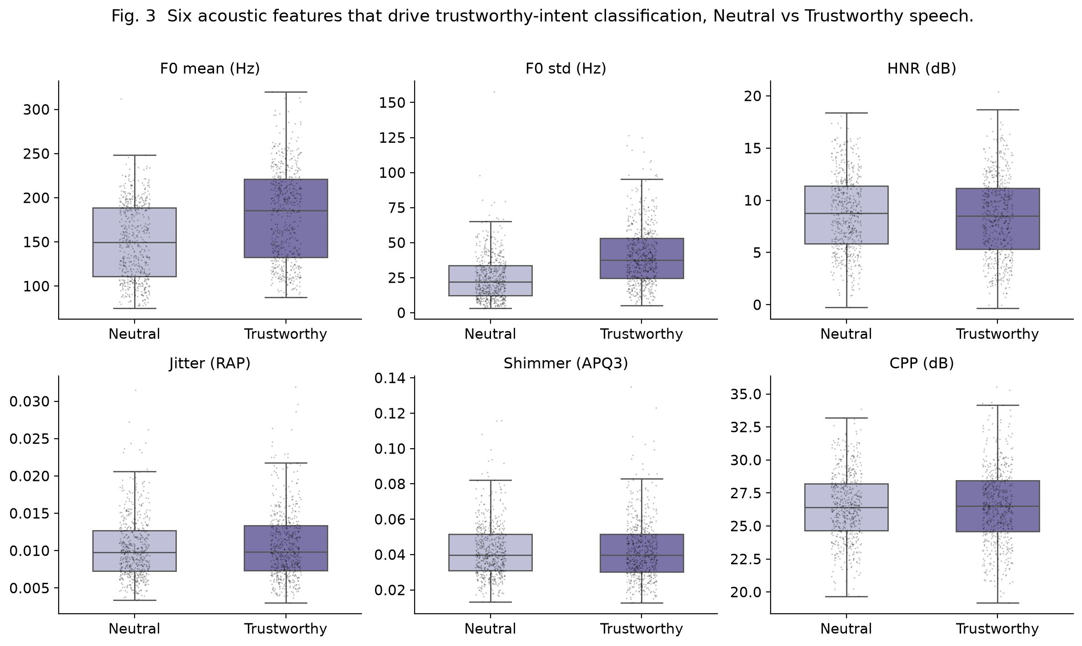

Figure 1. Six acoustic features that drive trustworthy-intent classification, Neutral vs Trustworthy speech

The distributions of six acoustic features by intent label (Neutral vs. Trustworthy), pooled across all speakers. Boxes show interquartile range and median; points show individual utterances. Trustworthy utterances show higher F0 mean and F0 SD, while HNR, jitter (RAP), shimmer (APQ3), and CPP overlap heavily between conditions.

3) Pre-processing:
The pre-processing pipeline is intentionally minimal and identical across all five models, so any performance difference can be attributed to the model itself. Speaker_Intent is mapped to a binary target using sklearn.preprocessing.LabelEncoder (Neutral → 0, Trustworthy → 1), and for DANN-Trust, Speaker_Ethnicity is independently encoded to a 3-class integer label using a second LabelEncoder instance. Any ±inf values produced by VoiceLab (e.g., division by zero in voice-quality calculations) are first replaced with NaN, and all remaining NaN values are imputed with the column mean. All 60 acoustic features are then standardized with sklearn.preprocessing.StandardScaler, fit on the training subset only and applied to both train and test. This standardization is needed for the linear baselines (Logistic Regression is scale-sensitive) and beneficial for the deep models (faster convergence of Adam under unit-variance inputs).

Finally, we split the corpus 80/20 into train (921 utterances) and held-out test (231 utterances) using train_test_split with random_state = 42 and a joint stratification key that combines intent and ethnicity into six cells (2 intents×3 ethnicities). Stratifying on intent alone, as the source paper effectively does under leave-one-speaker-out cross-validation, lets the test set's ethnicity composition drift, which we observed in pilot experiments to inflate per-ethnicity accuracy variance by a factor of two to three; joint stratification stabilizes per-ethnicity estimates and is the reason the gap standard deviations reported in Section IV-E are interpretable. Furthermore, our 80/20 results accordingly sit 2.4 and 2.9 percentage points above the published LOSO results for Random Forest and Logistic Regression respectively (Section IV-B), which we attribute to the evaluation protocol rather than to any improvement in the models themselves.

B. Original analysis recap
The source paper validated the corpus with two classifiers evaluated under leave-one-speaker-out (LOSO) cross-validation: a Random Forest with 126 trees and a Logistic Regression baseline, both using all extracted acoustic features to separate Neutral from Trustworthy speech [20]. The two models performed comparably at the aggregate level, with overall classification accuracy of approximately 71% for RF and 69% for LR, and AUC values of 71 to 77% for RF and 72 to 78% for LR. Splitting the results by ethnicity, however, exposed uneven per-group performance. For instance, the White cells classified well, while accuracy dropped and became less stable for Black and South Asian speakers, an effect the authors attribute to the small and unbalanced older cells in those groups. Measuring and reducing this per-group disparity is the aim of the fairness formulation and baseline re-implementations developed in Section III.

C. A note on label validity
One caveat qualifies the results reported below. The Trustworthy label records a speaker's own attempt to sound trustworthy, that is, their production intent, not a listener's rating of how trustworthy the utterance actually sounds. Classifying intent is therefore not the same as classifying perceived trust, and a model that separates the two conditions well need not track the impression a listener would form. Pairing these recordings with listener trust ratings would allow the two framings to be compared directly, and we identify this as a natural extension for future work.

III. METHODOLOGY
A. Diagram
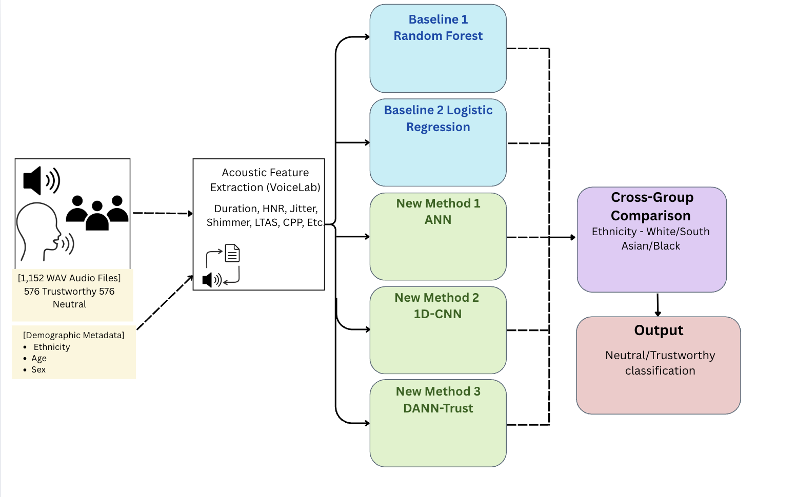
Figure 2. The end-to-end pipeline of the Echoes to Equity study.

B. Problem Formulation

We create a trustworthy intent classification system through a supervised binary classification with a focus on fairness, where y = 0 denotes neutral intent and y = 1 denotes trustworthy intent. Each utterance is characterized by a 60-dimensional acoustic feature vector x ∈ ℝ⁶⁰ extracted by VoiceLab, and comprised into a family of acoustic features (pitch (F0) statistics, jitter variants (RAP, PPQ5, DDP), shimmer variants (APQ3, APQ5, APQ11), harmonics-to-noise ratio (HNR), cepstral peak prominence (CPP), formant measures (F1–F4), long-term average spectrum (LTAS) features, etc). Each utterance has an additional demographic representation g, used to model fairness between demographic groups. The present framework focuses on ethnicity, where g ∈ {White, South-Asian, Black}.

In order to identify ‘fairness,’ we define the fairness gap as the difference between the maximum and minimum per-group accuracy. Δeth = max_z Acc(z) − min_z Acc(z), where Δeth is the fairness gap across ethnicity and Acc(z) is the model’s accuracy of an utterance of a specific demographic group z. A smaller fairness gap indicates more equitable performance between each demographic group. This is the metric that is the basis for fair demographic comparison of all models.

C. Baselines
In our framework, we re-implement two classical classification models used in the original dataset validation by Maltezou-Papastylianou et al. [20]. Both baselines use a fixed random seed (random_state = 42) for reproducibility and are trained on the same 80/20 train-test split. Additionally, the split is jointly stratified by intent and ethnicity in which all six cells (2 intents)×(3 ethnicities) keep their proportion in both training and testing. This is used to correct the demographic composition from drifting and distorting per-group accuracy. All 60 features are standardized using StandardScaler fitted on the training set, ensuring a fair comparison with the new architectures in the following sections. The first re-implementation, Random Forest (RF), is an ensemble classifier that aggregates predictions across several independent trees to reach one majority conclusion. We configure it with 100 trees and a maximum depth of 10, whereas Maltezou-Papastylianou et al. [20] uses a 126-tree configuration. The second is a Logistic Regression (LR), a linear classifier that separates the acoustic cue between trustworthy and neutral speech through a weighted decision boundary.

However, one critical issue is that both baselines view the speaker population homogeneously, fitting the demographic within one decision boundary. This pooling obscures the possibility that acoustic features may differ across demographic groups, leading to systematically different accuracy across groups. For instance, Maltezou-Papastylianou et al. [20] report RF accuracy of 71% for White speakers but declined to 68% and 66%, respectively, for Black and South Asian speakers, suggesting that the model's distinction pattern of trust is skewed toward one demographic group best represented in the data. To reduce disparity between demographic groups, we propose three novel architectures.

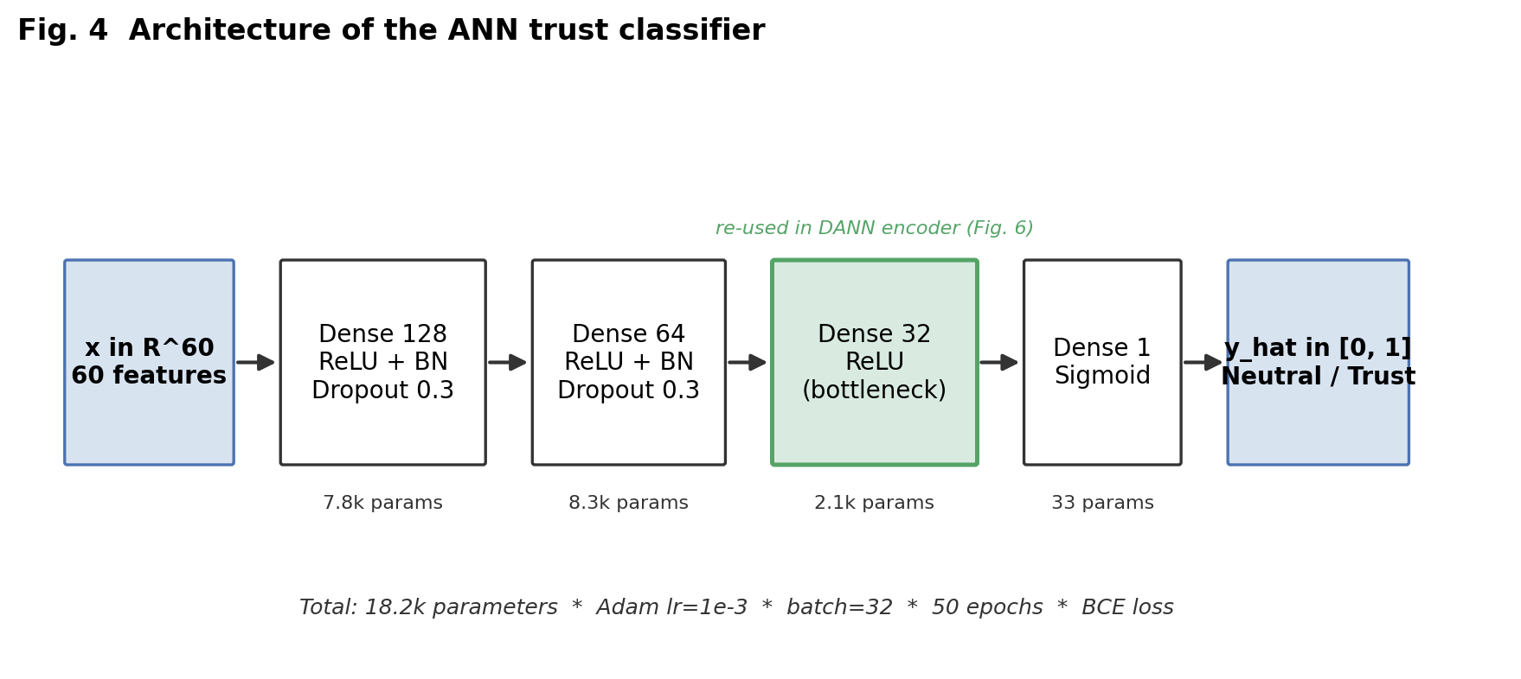
Figure 3. Architecture of the ANN trust classifier

D. New Method #1
The first proposed architecture introduces a connected feedforward Artificial Neural Network (ANN), which will assess if a greater representational capacity over the baseline models can improve overall accuracy and consistency across demographic groups. The network takes the full set of acoustic features (F0, HNR, etc.) as inputs and passes it through three hidden layers that decrease in width: 128, 64, and 32, neurons respectively, each using the ReLU activation function. Due to the limited training set of 921 samples, overfitting may occur. To mitigate this, Dropout (rate 0.3) [41] and Batch Normalization [42] are applied to the first two hidden layers. Lastly, the output layer applies a sigmoid activation to determine the probability of trustworthiness. Furthermore, the model was deliberately kept at three layers as previous experiments showed that additional layers led to diminishing results and overfitting, which reflects the dataset's size as a binding constraint on model capacity. The model is trained for 50 epochs using the Adam optimizer [43] (learning rate 10⁻³) with a batch size of 32 and binary cross-entropy loss.

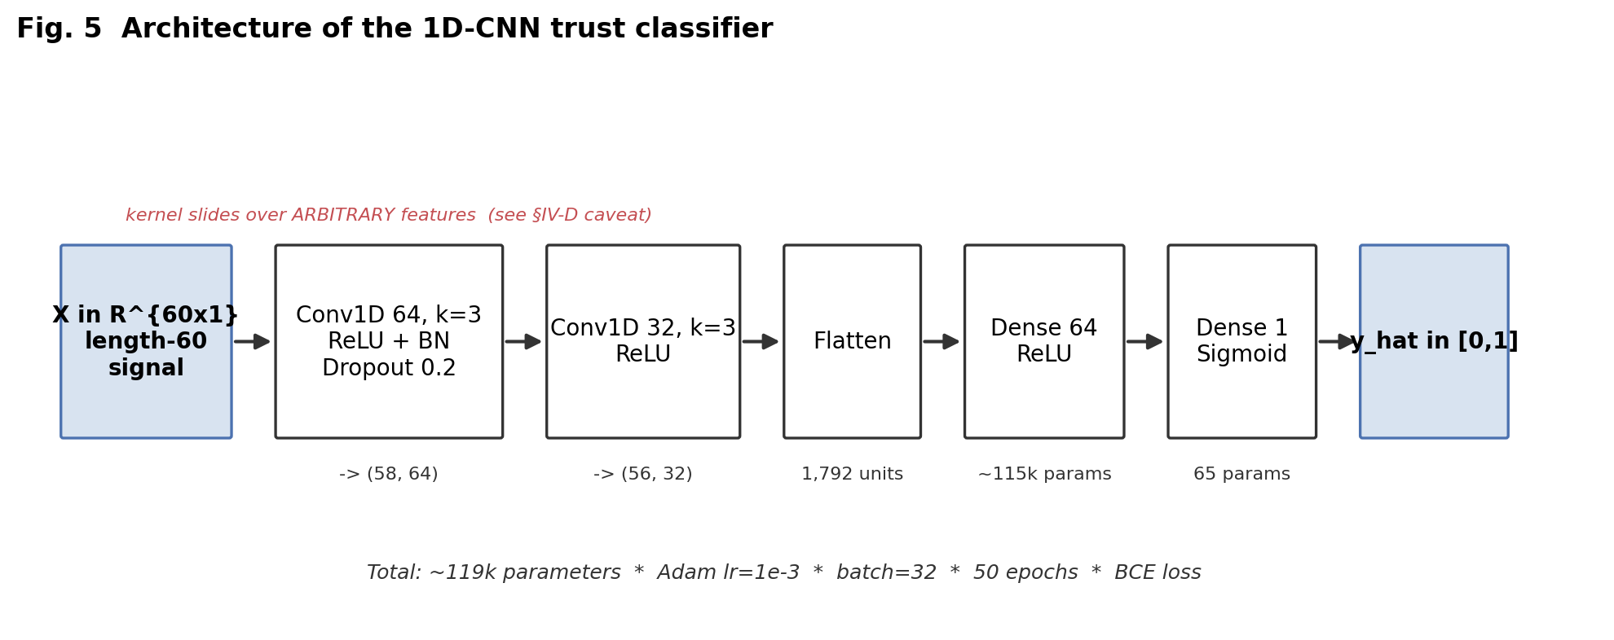
Figure 4. Architecture of the 1D-CNN trust classifier

E. New Method #2
The second proposed architecture is a 1D Convolutional Neural Network (1D-CNN) [44] that processes the acoustic feature set by sliding a convolutional window across it to detect local patterns between adjacent features. The model is trained under conditions identical to the ANN: the Adam optimizer (learning rate 10⁻³), a batch size of 32, 50 epochs, and binary cross-entropy loss. While ANN treats inputs as independent entities, CNN assumes adjacent features are related. It is important to note that the 60 VoiceLab features have no meaningful spatial ordering. The order of adjacent positions in the feature vector is accidental, not intended for acoustic importance, so the CNN's locality assumption is deliberately mismatched to the data. Therefore, the 1D-CNN was included as a control experiment rather than as a competitive model expected to exploit local structure. Additionally, each feature vector is reshaped from x ∈ ℝ⁶⁰ to X ∈ ℝ⁶⁰ˣ¹ to match the input format that convolutional layers require (batch, length, channels). x∈R60 to X∈R60×1 The architecture consists of two convolutional layers with 64 and 32 filters respectively, each with a kernel size of 3 and ReLU activation. In the first convolutional layer, each filter independently examines three adjacent features at a time as it slides across the vector, followed by Batch Normalization and Dropout (rate 0.2). The second convolutional layer applies the same processing by extracting lower-level patterns detected in the first layer and combining them into higher-level representations. This is followed by a flattened layer, a dense layer of 64 neurons, and a sigmoid output for determining the probability of trustworthy speech. If a model whose primary inductive bias is locality nonetheless matches the ANN's accuracy and fairness, then the gain over RF and LR can be attributed to depth and non-linearity in general.

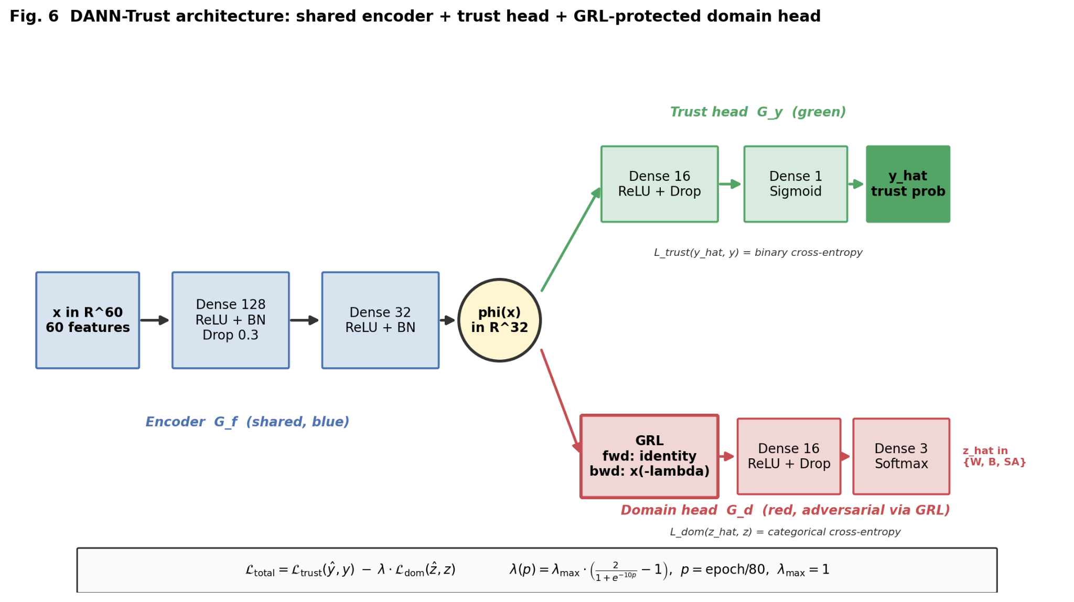

Figure 5. DANN-Trust architecture: shared encoder + trust head + GRL-protected domain head

F. New Method #3

While ANN and CNN improve overall accuracy, their encoders can begin to use ethnicity-linked acoustic features to predict trustworthiness, producing per-group performance differences even in the absence of any explicit demographic input. To reduce this reliance, we introduce DANN-Trust, a Domain-Adversarial Neural Network [26]. The architecture consists of a shared encoder feeding two heads: a trust head that predicts the binary label, and a domain (ethnicity) head connected through a Gradient Reversal Layer (GRL). During backpropagation the GRL multiplies the domain-head gradient by -λ, so the encoder is trained to remove information the domain head could use, while the trust head is trained normally. Importantly, the encoder in DANN-Trust omits BatchNormalization: the ablation in Section IV-F shows that including BN with adversarial training significantly harms both trust accuracy (Mann-Whitney U, p=0.002) and the ethnicity gap (p=0.011), and inflates gap variance (Levene's, p=0.049). We interpret this as running batch statistics being unstable when the encoder's representation is being continuously reshaped by the adversarial signal on a small (n≈921 training) tabular dataset.

Additionally, the strength of the gradient reversal is gradually increased over the course of training to prevent destabilization of the encoder from adversarial pressure before it can predict trustworthiness. This strength is governed by a parameter λ, following the schedule proposed by Ganin et al. [26]:
λ(p) = 2 / (1 + exp(−10p)) − 1 , where p represents the pressure of GRL, defined by the current epoch divided by the total number of epochs. By initializing the pressure of GRL near zero, this allows the encoder to develop trust-discriminative features before maximizing the pressure to 1.0. DANN-Trust is trained for 80 epochs to accommodate the complexity of the model. Training uses the Adam optimizer (learning rate 10⁻³) with a batch size of 32, and the adversarial strength is capped at a maximum value of λ_max = 1.0.

G. Evaluation Metrics and Multi-Seed Protocol

For every model, we report overall accuracy computed on the fully held-out test set together with the area under the ROC curve (AUC), which gives a threshold-independent view of discriminability. Both are also disaggregated by speaker ethnicity, the paper's primary fairness axis.

We quantify the fairness gap using Δ_eth as defined in Section III-B. A smaller gap denotes more even performance across groups. Because accuracy gaps and AUC gaps may move independently, we also report an AUC fairness gap, computed the same way on per-group AUC values.

Each model is trained 50 times with seeds {42, 43, ..., 91} on the same fixed train/test partition (split seed = 42). The partition is fixed for two reasons. First, to prevent data contamination, feature standardization is fit on the training split only and then applied to the test split. Second, holding the split fixed isolates model variance, the shift in a retrained model's behavior on identical data, from split variance, the contribution of the partition itself. Measuring seed-to-seed variance therefore allows us to test with statistical rigour whether DANN-Trust is not only fairer on average than the baselines but also whether it is more consistent across retraining than the CNN.

IV. EXPERIMENT AND RESULTS

In the experimental evaluation, we conducted a multi-seed comparative analysis of the five trustworthy-intent classifiers introduced in the methodology section. As described in Section III-C, Random Forest and Logistic Regression are reproduced–established baselines from Maltezou-Papastylianou et al. [20] and are relatively mature, well-understood methods; our re-implementation of them serves primarily as a reference point rather than a contribution in its own right. Hence, our experimental evaluation focuses mainly on three components that are novel to this work: the ANN and 1D-CNN as general-purpose deep baselines (Sections III-D and III-E), and DANN-Trust, the domain-adversarial network that is this paper's central contribution (Section III-F). Specifically, the experiments assess (1) whether depth and non-linearity alone improve accuracy and reduce demographic disparity over RF and LR, and (2) whether DANN-Trust's adversarial mechanism yields fairness behavior that is not only better on average but more stable across retrains, which is the property that determines whether such a method is deployable in practice.

Section IV-A describes the shared experimental setup. Section IV-B presents overall classification performance (Table 2). Section IV-C decomposes accuracy by speaker ethnicity, the paper's primary fairness axis (Table 3, Fig. 6). Section IV-D summarizes AUC results by ethnicity (Table 4). Section IV-E quantifies the variance of every model's accuracy and fairness behavior across the 50 random initializations (Table 5, Fig. 7). Section IV-F reports an ablation on the DANN encoder architecture (Table 6). A per-age and per-sex breakdown supporting the sex-gap finding discussed in Section V appears as Fig. 8.

A. Experimental Setup
All experiments use Python 3.11, scikit-learn 1.4 and TensorFlow 2.20 on commodity hardware. The split between training (921 utterances) and held-out test (231 utterances) is performed once with random_state = 42, using joint stratification on the cross-product of intent (Neutral, Trustworthy) and ethnicity (White, Black, South Asian), so that all six cells preserve their corpus proportions in both halves. The held-out test set contains 48 Neutral and 48 Trustworthy White utterances, 34 and 34 Black, and 33 and 34 South Asian.

Each model is trained 50 times with initialization seeds {42, 43, ..., 91} on an identical split, and all reported numbers are the mean across the 50 seeds with the standard deviation reported as uncertainty. Pairwise comparisons between models use the Mann-Whitney U test on the seed-level metric distributions (means), and Levene's test on their spreads (variances). This protocol isolates model variance from split variance and is what allows the stability claims of Section IV-E to be tested statistically.

Random Forest uses n_estimators = 100 and max_depth = 10 while Logistic Regression uses the liblinear solver. The deep models are trained with Adam at learning rate 10⁻³, batch size 32, binary cross-entropy on the trust head. DANN-Trust is trained by a categorical cross-entropy on the ethnicity head with the gradient-reversal layer described in Section III-F. ANN and CNN train for 50 epochs; DANN-Trust trains for 80.
B. Overall Classification Performance
Table 2 summarizes overall accuracy, AUC and per-ethnicity fairness gap for all five models. The two baselines reach 73.05% and 71.86% accuracy under our split, recovering the source paper's published 71% and 69% [20, Table 8] within three percentage points. However, our re-implementation differs from the published analysis in three ways: (i), It uses all 60 acoustic columns released in the feature CSV, whereas the source paper's validation analysis used a ten-feature subset comprising duration, F0 mean and standard deviation, HNR, jitter (RAP), shimmer (APQ3), CPP, and three LTAS descriptors. (ii), it evaluates on a joint-stratified 80/20 split rather than leave-one-speaker-out cross-validation. (iii), our Random Forest uses 100 trees at a maximum depth of 10, against the 126 trees reported in the source paper. The small increase over the published results is best attributed to our random 80/20 split being an easier evaluation protocol than the source paper's leave-one-speaker-out cross-validation.

Table 2. Overall accuracy and AUC on the TIS Corpus held-out test set (mean ± std over 50 seeds; joint-stratified 80/20 split, split seed = 42).

Model | Accuracy | AUC | Fairness gap Δeth
RF | 73.05 ± 1.27% | 0.818 ± 0.007 | 12.29 ± 3.02 pp
LR | 71.86 ± 0.00% | 0.803 ± 0.000 | 11.34 ± 0.00 pp
ANN | 76.25 ± 1.60% | 0.821 ± 0.009 | 7.99 ± 3.56 pp
CNN | 76.15 ± 1.75% | 0.828 ± 0.010 | 5.78 ± 2.70 pp
DANN | 76.21 ± 1.71% | 0.828 ± 0.011 | 6.34 ± 3.11 pp

All three deep models exceed the RF baseline by 3.10 to 3.20 percentage points and the LR baseline by 4.29 to 4.39 pp (Mann-Whitney U, all pairwise p<10⁻⁴). The per-ethnicity fairness gap Δ_eth collapses from 12.29 pp (RF) and 11.34 pp (LR) to 5.78 pp (CNN) and 6.34 pp (DANN-Trust). CNN and DANN-Trust are statistically indistinguishable on overall accuracy (p=0.86) and on Δ_eth (p=0.26). CNN and DANN each significantly beat ANN on Δ_eth (p=0.001 and p=0.022 respectively). The overall AUC values (0.80–0.83 across all five models) sit above the source paper's published 0.77 for RF and 0.76 for LR [20, Table 10], for the same protocol reason as above (joint-stratified split versus LOSO). Separately, the five models' AUC values are tightly clustered relative to their differences in accuracy, suggesting that most of the accuracy advantage of the deep models comes from better-calibrated decision thresholds rather than from a fundamentally more separable representation.

C. Per Ethnicity Comparison
Table 3. decomposes the headline numbers of Table 2 by speaker ethnicity.

Table 3: Per-ethnicity trust accuracy (mean ± std over 50 seeds).
Model | White (N=96) | Black (N=68) | South Asian (N=67) | Δ (gap)
RF | 78.71 ± 1.76% | 71.35 ± 2.72% | 66.66 ± 2.87% | 12.29 ± 3.02 pp
LR | 76.04 ± 0.00% | 64.71 ± 0.00% | 73.13 ± 0.00% | 11.34 ± 0.00 pp
ANN | 79.25 ± 3.00% | 73.18 ± 2.84% | 75.07 ± 3.48% | 7.99 ± 3.56 pp
CNN | 77.12 ± 2.12% | 74.79 ± 3.73% | 76.12 ± 3.49% | 5.78 ± 2.70 pp
DANN | 78.46 ± 2.67% | 74.24 ± 2.92% | 74.99 ± 3.15% | 6.34 ± 3.11 pp

The pattern is clearest on the South Asian subset, where Random Forest reaches only 66.66% accuracy, 12.05 percentage points below the White group, replicating the source paper's finding that this group is hardest for its tree-based classifier [20, Table 8]. The deep models raise South Asian accuracy by roughly 8 to 10 points, closing most of that distance (ANN 75.07%, CNN 76.12%, DANN 74.99%).
Our baseline gaps of 12.29 pp for Random Forest and 11.34 pp for Logistic Regression are roughly two to three times the 5 pp and 4 pp spreads in the published results [20, Table 8], most likely because each per-group accuracy is estimated here from between 67 and 96 test utterances rather than from the full corpus under leave-one-speaker-out. Comparisons in this section are therefore between models evaluated under our protocol. The two baselines also disagree on which group is hardest for them individually: RF's weakest subset is South Asian (66.66%) while LR's is Black (64.71%). Because these are two different classifiers trained on the same features and the same split, this indicates that each baseline is finding a different demographic shortcut rather than one group being intrinsically harder to classify. Therefore, subset accuracy depends on the choice of model, not solely on the underlying acoustics.
Among the three deep models, CNN has the flattest per-ethnicity mean profile at 50 seeds, with only 2.33 percentage points separating its highest (White, 77.12%) and lowest (Black, 74.79%) group means, followed by DANN-Trust with 4.22 pp (White 78.46% vs Black 74.24%). The 5.78 pp and 6.34 pp mean values reported for their Δ_eth in Table 2 are larger than these mean-of-means differences because Δ_eth is computed within each seed before averaging, and the identity of the extreme groups varies across seeds. The 50-seed protocol also stabilizes the per-group standard deviations: at 50 seeds every deep model sits between roughly 2 and 4 pp of per-group std, so the earlier appearance of one model being uniformly more stable per group than another does not hold up once seed count is increased.

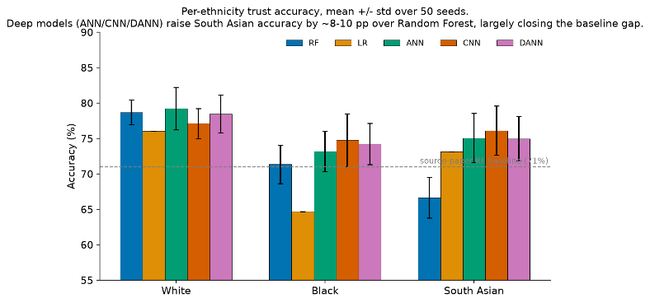

Figure 6. Per-ethnicity trust accuracy, mean +/- std over 50 seeds. Deep models (ANN/CNN/DANN) raise South Asian accuracy by ~8-10 pp over Random Forest, largely closing the baseline gap.

D. AUC Summary
Table 4 mirrors Table 10 of the source paper, computed on our split and averaged over 50 seeds.
Table 4. Per-ethnicity AUC
Model | White AUC | Black AUC | South Asian AUC | Δ_eth (AUC)
RF | 0.889 ± 0.011 | 0.777 ± 0.020 | 0.754 ± 0.018 | 0.135
LR | 0.873 ± 0.000 | 0.721 ± 0.000 | 0.784 ± 0.000 | 0.152
ANN | 0.861 ± 0.022 | 0.782 ± 0.019 | 0.807 ± 0.024 | 0.079
CNN | 0.845 ± 0.013 | 0.790 ± 0.022 | 0.845 ± 0.021 | 0.055
DANN | 0.861 ± 0.013 | 0.796 ± 0.021 | 0.817 ± 0.022 | 0.065

Overall, Black speakers form the weakest AUC cell for four of the five models (LR 0.721, ANN 0.782, CNN 0.790, DANN 0.796), with LR's 0.721 the lowest value in the table. This is consistent with LR's 64.71% accuracy for the same group in Table 3 and suggests that a linear decision boundary is less proficient at separating Trustworthy from Neutral speech for this subset. Random Forest is the exception: its weakest cell is South Asian (0.754), while its White cell is the strongest value in the table (0.889), giving it the widest AUC spread alongside the widest accuracy gap (Table 2). LR shows the reverse ordering, holding the widest AUC spread (0.152) but the narrower of the two baseline accuracy gaps, an early indication that the two measures do not rank models identically.

This reflects Section IV-C, where RF and LR disagree on which subset is harder to classify. RF's weakest group is South Asian in both tables, while LR's is Black in both. AUC does not depend on the decision threshold, so the difference is not a consequence of threshold placement. Each classifier appears to rely on a different demographic shortcut rather than one group being intrinsically harder to classify. The two models with the narrowest AUC spreads are also the two with the narrowest accuracy gaps: CNN at 0.055 and DANN-Trust at 0.065, against 0.079 for the ANN and 0.135 and 0.152 for the baselines. The same inflation seen in the accuracy gaps appears here: the source paper's RF AUC spans 6 pp across ethnicity under LOSO [20, Table 10] against 13.5 pp under our split, consistent with the smaller per-group samples described in Section IV-C.

E. Variance and Stability Across Seeds
A central methodological question of this paper is whether DANN-Trust is more stable across retraining than the CNN. Table 5 collects each model's seed-to-seed standard deviation on the two metrics that matter most when deciding fairness behavior: overall accuracy and the per-ethnicity fairness gap Δ_eth, now measured across 50 random seeds.
Table 5. Across-seed standard deviation of overall accuracy and fairness gap (50 seeds, same fixed split).
Model | Accuracy std | Δ_eth std (pp)
RF | 1.27% | 3.02
LR | 0.00% | 0.00
ANN | 1.60% | 3.56
CNN | 1.75% | 2.70
DANN | 1.71% | 3.11
The 50-seed variances no longer support a stability advantage for DANN-Trust over the CNN. On accuracy, CNN std = 1.75% and DANN std = 1.71% (Levene's W-test p=0.97); on Δ_eth, CNN std = 2.70 pp and DANN std = 3.11 pp (p=0.33). LR's zero variance is a diagnostic on the harness rather than a finding about LR itself: a deterministic solver with a fixed random state produces identical solutions across reseeds. The apparent DANN stability advantage reported in an earlier five-seed version of this analysis (CNN Δ_eth std ≈ 2.87 pp vs DANN ≈ 0.89 pp) did not survive the seed-count increase; with only five seeds a single lucky run collapses the estimated std by a factor of three, and the effect disappears once each estimate is drawn from 50 runs. All three deep models do show significantly higher accuracy std than Random Forest (Levene's p<0.03 for each), but among the deep models themselves no pair differs significantly on the stability of any reported metric. The methodological lesson stands independent of the direction of the result: reporting fairness from a single training run, or from only a handful of seeds, can produce a stability claim that a larger seed count would overturn.

CNN and DANN-Trust occupy essentially the same region of the plane; their error bars overlap on both axes.

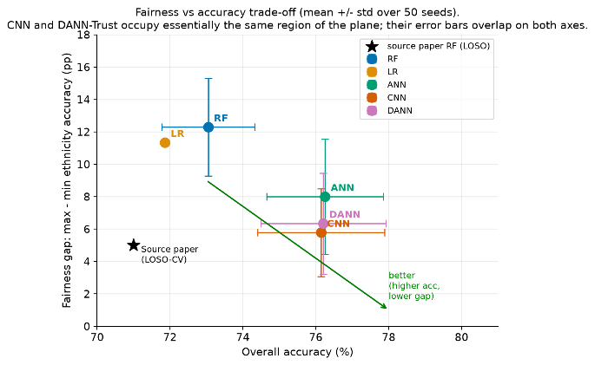
Figure 7. Fairness vs accuracy trade-off (mean ± std over 50 seeds).
F. Ablation: BatchNormalization in the DANN encoder
Table 6. DANN encoder ablation.
Variant | Accuracy | Δ_eth mean (pp) | Δ_eth std (pp)
dann_full | 75.48 ± 2.15 % | 8.68 | 4.40
dann_no_bn | 76.91 ± 1.84 % | 6.55 | 3.14
p-value | 0.002 (**) | 0.011 (**) | 0.049 (*)

dann_full includes two BatchNormalization layers in the encoder; dann_no_bn omits both. 50 seeds each, same fixed 80/20 split. p-values are two-sided Mann-Whitney U on means, and Levene's on variances. Bold entries are significant at p<0.05.
Removing BatchNormalization from the DANN-Trust encoder is a triple-significant improvement: accuracy rises by 1.43 pp (Mann-Whitney U, p=0.002), the mean ethnicity gap tightens by 2.13 pp (p=0.011), and the seed-to-seed variance of that gap contracts as well (Levene's p=0.049). The interpretation adopted in Section III-F is that running batch statistics are unstable when the encoder representation is being continuously reshaped by adversarial pressure on a small tabular training set (~921 utterances). All main-body DANN-Trust results in Sections IV-B through IV-E use the dann_no_bn configuration.

V. DISCUSSION
A. Summary and interpretation of results
At 50 seeds, all three deep models outperform the published Random Forest and Logistic Regression baselines on both accuracy and per-ethnicity fairness. Among the deep models, CNN and DANN-Trust are statistically indistinguishable on every headline metric considered here, so neither can be presented as strictly better than the other on this corpus.
Relative to Random Forest, ANN improved overall accuracy by 3.20 pp, CNN by 3.10 pp, and DANN-Trust by 3.16 pp (Mann-Whitney U, all p<10⁻⁴). Over the same 50 seeds, the per-ethnicity accuracy gap decreased from 12.29 pp under Random Forest to 5.78 pp for the CNN and 6.34 pp for DANN-Trust. The largest per-group improvement is on South Asian speakers, whose mean accuracy rises from 66.66% under Random Forest to 76.12% under CNN and 74.99% under DANN-Trust. These results support the interpretation that the ~71% accuracy reported in the original TIS study was not a ceiling imposed by the corpus but was partly attributable to the model classes originally evaluated. The improvement of the neural models is also consistent with previous research indicating that no single acoustic cue reliably characterizes vocal trustworthiness; the trait may depend on interactions among multiple features that nonlinear models capture more effectively than the published linear and tree-based baselines.
CNN and DANN-Trust could not be separated on point estimates of accuracy (76.15% vs 76.21%, p=0.86) or on the mean per-ethnicity gap (5.78 pp vs 6.34 pp, p=0.26). At five seeds an earlier version of this analysis reported that DANN-Trust was substantially more stable than CNN on the fairness gap (std 0.89 pp vs 2.87 pp). At 50 seeds that advantage disappears: CNN std = 2.70 pp, DANN std = 3.11 pp, Levene's p=0.33 for the difference; the earlier low DANN estimate was a low-seed-count artefact rather than a property of adversarial training.
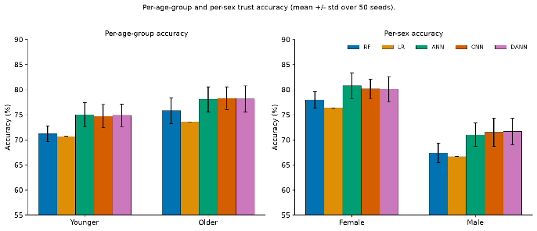
Figure 8. Per-age and per-sex trust accuracy, mean +/- std over 50 seeds.

The male-speaker bar (right) narrows visibly under CNN and DANN-Trust relative to Random Forest and Logistic Regression, mirroring the significant sex-gap reductions reported in the text (Mann-Whitney U, p=0.003 for CNN, p=0.002 for DANN).
Figure 8 disaggregates overall accuracy by age group and by speaker sex. A separate finding at 50 seeds concerns the sex axis, which the corpus was not originally designed to control. Both CNN and DANN-Trust significantly reduce the female-vs-male accuracy gap relative to Random Forest (10.63 pp → 8.69 pp for CNN, p=0.003; → 8.48 pp for DANN-Trust, p=0.002); ANN does not (p=0.16). All three deep models simultaneously have significantly higher sex-gap variance than Random Forest (Levene's p<0.02), so any single training run of a deep model could over- or under-shoot the reported mean by several pp. The age gap is small for every model (2.9–4.8 pp) and only the ANN significantly beats Random Forest on it (p=0.046). No deep model is significantly different from any other on the age gap.
The ablation reported in Section IV-F explains one architectural choice in the DANN-Trust encoder. Retraining DANN with BatchNormalization inserted at the same positions as in the ANN encoder produces a significantly worse model on all three axes the ablation measures: overall accuracy (dann_no_bn 76.91% vs dann_full 75.48%, Mann-Whitney U p=0.002), mean Δ_eth (6.55 pp vs 8.68 pp, p=0.011), and Δ_eth variance (std 3.14 pp vs 4.40 pp, Levene's p=0.049). We interpret this as running batch statistics being unstable when the encoder's representation is being continuously reshaped by the adversarial signal on a small tabular dataset. This is the reason the DANN-Trust architecture reported in the main tables is the no-BN configuration, and it supports the broader point that architectural details such as normalization layers should be treated as first-order fairness variables, not incidental implementation choices.

B. What does “Fair” mean here?
On this corpus and under the accuracy-gap metric used here, both CNN and DANN-Trust produce among the smallest per-ethnicity disparities observed while maintaining competitive overall accuracy. Neither model should be described as demographically invariant or universally fair in a stronger sense: the Δ metric measures only equalized per-group accuracy on the trust decision, not representation-level invariance, per-group error types, or equalized odds. The case for choosing CNN over DANN-Trust (or vice versa) on this corpus therefore rests on considerations outside the measured metrics — implementation complexity, interpretability, and behavior on future related datasets — since the two are statistically indistinguishable on every metric reported here. Whether the DANN-Trust encoder's internal representation is demographically invariant at the representation level (as opposed to at the decision level) is not evaluated here and remains an open question for future work.

To isolate which component of DANN-Trust drives the stability advantage, we retrained four variants on the same fixed split and five seeds (Table 8). Removing the gradient-reversal layer (no_grl) reduces to a plain multi-task learner; removing the domain head entirely (no_domain) reduces to a plain ANN with the same encoder shape. If DANN's stability came from architectural regularization rather than the adversary, no_grl and no_domain would match the full model.

C. Limitations & Future work
Several limitations should guide the interpretation of these findings. First, the study still uses a single fixed train-test split. This design deliberately isolates variation caused by stochastic training but does not measure variation across different data partitions; future work should combine repeated seeds with repeated train-test splits. Second, the findings are limited to the TIS Corpus (1,152 utterances from three ethnic groups). Some demographic cells contain relatively few speakers, limiting the precision of per-group estimates. Third, the fairness metric Δ measures only the maximum-minus-minimum of per-group accuracy. It does not capture differences in error types; future studies should supplement accuracy gaps with per-group false-positive and false-negative rates and with equalized-odds or calibration-based metrics. Fourth, the ablation isolates BatchNormalization but does not systematically vary the gradient-reversal schedule, the adversarial-head capacity, or the encoder width; these remain plausible axes for further study. Fifth, results here concern speaker intent (produced trustworthiness) rather than listener perception; generalization to perception-labelled corpora is not established.

VI. CONCLUSION
This project set out to reduce a demographic disparity in voice-trust classification and found that much of it was not a property of the data at all. The accuracy ceiling reported for this corpus belonged to the model class rather than the data, and most of the ethnicity disparity disappeared once that ceiling was lifted, before any fairness objective was applied. Under a 50-seed statistical protocol, CNN and DANN-Trust are indistinguishable on accuracy, ethnicity gap, and sex gap; a stability advantage for DANN-Trust that appeared at five seeds did not survive the seed-count increase. Both deep models additionally close a significant portion of the female-vs-male accuracy gap relative to the classical baselines. A supporting ablation shows that BatchNormalization in the DANN encoder significantly harms every fairness metric it was intended to help, so the reported DANN-Trust architecture omits it.
These findings carry three implications for speech-based AI. First, because the TIS Corpus labels speaker intent rather than listener perception, the observed performance differences across groups concern how speakers produce trustworthy intent, not how listeners judge their voices; systems trained on listener perceptions risk treating shared expectations about how a trustworthy voice should sound as objective properties of the speaker. Second, future systems should evaluate demographic performance not only by auditing average accuracy across groups but also by treating fairness metrics as distributions over independent retrains, with statistical tests on both means and variances. Third, architectural components that are usually considered incidental (normalization layers, adversarial-head width, gradient-reversal schedule) can dominate the fairness outcome and should therefore be reported and ablated alongside the loss function itself.

REFERENCES
[1] J. Kreiman and D. Sidtis, Foundations of Voice Studies: An Interdisciplinary Approach to Voice Production and Perception. Wiley, 2011.
[2] M. Latinus and P. Belin, "Human voice perception," Current Biology, vol. 21, no. 4, pp. R143–R145, 2011.
[3] P. McAleer, A. Todorov, and P. Belin, "How do you say 'hello'? Personality impressions from brief novel voices," PLoS ONE, vol. 9, no. 3, e90779, 2014.
[4] P. Belin, B. Boehme, and P. McAleer, "The sound of trustworthiness: Acoustic-based modulation of perceived voice personality," PLoS ONE, vol. 12, no. 10, e0185651, 2017, doi: 10.1371/journal.pone.0185651.
[5] T. Purnell, W. Idsardi, and J. Baugh, "Perceptual and phonetic experiments on American English dialect identification," Journal of Language and Social Psychology, vol. 18, no. 1, pp. 10–30, 1999.
[6] C. Maltezou-Papastylianou, R. Scherer, and S. Paulmann, "How do voice acoustics affect the perceived trustworthiness of a speaker? A systematic review," Frontiers in Psychology, vol. 16, 2025.
[7] A. Koenecke, A. Nam, E. Lake, J. Nudell, M. Quartey, Z. Mengesha, C. Toups, J. R. Rickford, D. Jurafsky, and S. Goel, "Racial disparities in automated speech recognition," PNAS, vol. 117, no. 14, pp. 7684–7689, 2020.
[8] N. N. Oosterhof and A. Todorov, "The functional basis of face evaluation," PNAS, vol. 105, no. 32, pp. 11087–11092, 2008.
[9] Belin, P., Bestelmeyer, P.E.G., Latinus, M. and Watson, R. (2011), Understanding Voice Perception. British Journal of Psychology, 102: 711-725. https://doi.org/10.1111/j.2044-8295.2011.02041.x
[10] E. Ponsot, J. J. Burred, P. Belin, and J.-J. Aucouturier, "Cracking the social code of speech prosody using reverse correlation," PNAS, vol. 115, no. 15, pp. 3972–3977, 2018.
[11] M. S. Tsantani, P. Belin, H. M. Paterson, and P. McAleer, "Low vocal pitch preference drives first impressions irrespective of context in male voices but not in female voices," Perception, vol. 45, no. 8, pp. 946–963, 2016.
[12] A. Oleszkiewicz, K. Pisanski, K. Lachowicz-Tabaczek, and A. Sorokowska, "Voice-based assessments of trustworthiness, competence, and warmth in blind and sighted adults," Psychonomic Bulletin & Review, vol. 24, no. 3, pp. 856–862, 2017.
[13] A. Schirmer, M. H. Chiu, C. Lo, Y.-J. Feng, and T. B. Penney, "Angry, old, male — and trustworthy? How expressive and person voice characteristics shape listener trust," PLoS ONE, vol. 15, no. 5, e0232431, 2020.
[14] C. A. Klofstad, R. C. Anderson, and S. Peters, "Sounds like a winner: Voice pitch influences perception of leadership capacity in both men and women," Proceedings of the Royal Society B, vol. 279, no. 1738, pp. 2698–2704, 2012.
[15] D. A. Puts, C. R. Hodges, R. A. Cárdenas, and S. J. C. Gaulin, "Men's voices as dominance signals: vocal fundamental and formant frequencies influence dominance attributions among men," Evolution and Human Behavior, vol. 28, no. 5, pp. 340–344, 2007.
[16] C. T. Ferrand, "Harmonics-to-noise ratio: an index of vocal aging," Journal of Voice, vol. 16, no. 4, pp. 480–487, 2002.
[17] C. Baus, P. McAleer, K. Marcoux, P. Belin, and A. Costa, "Forming social impressions from voices in native and foreign languages," Scientific Reports, vol. 9, art. 414, 2019.
[18] B. Schuller et al., "The INTERSPEECH 2012 Speaker Trait Challenge," in Proc. INTERSPEECH, 2012.
[19] B. Schuller et al., "A survey on perceived speaker traits: Personality, likability, pathology, and the first challenge," Computer Speech and Language, vol. 29, no. 1, pp. 100–131, 2015.
[20] C. Maltezou-Papastylianou, R. Scherer, and S. Paulmann, "Human voices communicating trustworthy intent: a demographically diverse speech audio dataset," Scientific Data, vol. 12, art. 921, 2025, doi: 10.1038/s41597-025-05267-3.
[21] C. Maltezou-Papastylianou, R. Scherer, and S. Paulmann, "Trustworthy Intent in Speech (TIS) Corpora Dataset," Open Science Framework, 2024, doi: 10.17605/OSF.IO/45D8J.
[22] R. Tatman, "Gender and dialect bias in YouTube's automatic captions," in Proc. First ACL Workshop on Ethics in NLP, 2017, pp. 53–59.
[23] M. Sap, D. Card, S. Gabriel, Y. Choi, and N. A. Smith, "The risk of racial bias in hate speech detection," in Proc. ACL, 2019, pp. 1668–1678.
[24] L. Taylor and K. S. Rommelfanger, "Mitigating white Western individualistic bias and creating more inclusive neuroscience," Nature Reviews Neuroscience, vol. 23, no. 7, pp. 389–390, 2022.
[25] M. Hardt, E. Price, and N. Srebro, "Equality of opportunity in supervised learning," in Proc. NeurIPS, 2016, pp. 3315–3323.
[26] Y. Ganin, E. Ustinova, H. Ajakan, P. Germain, H. Larochelle, F. Laviolette, M. Marchand, and V. Lempitsky, "Domain-adversarial training of neural networks," Journal of Machine Learning Research, vol. 17, no. 59, pp. 1–35, 2016.
[27] A. Beutel, J. Chen, Z. Zhao, and E. H. Chi, "Data decisions and theoretical implications when adversarially learning fair representations," in Proc. FAT/ML Workshop, 2017.
[28] D. Madras, E. Creager, T. Pitassi, and R. Zemel, "Learning adversarially fair and transferable representations," in Proc. ICML, 2018, pp. 3384–3393.
[29] B. H. Zhang, B. Lemoine, and M. Mitchell, "Mitigating unwanted biases with adversarial learning," in Proc. AAAI/ACM Conf. AI, Ethics, and Society (AIES), 2018, pp. 335–340.
[30] C. Wadsworth, F. Vera, and C. Piech, "Achieving fairness through adversarial learning: An application to recidivism prediction," in Proc. FAT/ML Workshop, 2018.
[31] M. Tu, Y. Tang, J. Huang, X. He, and B. Zhou, "Towards adversarial learning of speaker-invariant representation for speech emotion recognition," in Proc. IEEE ICASSP, 2019.
[32] A. D'Amour et al., "Underspecification presents challenges for credibility in modern machine learning," Journal of Machine Learning Research, vol. 23, no. 226, pp. 1–61, 2022.
[33] S. Qian, H. V. Pham, T. Lutellier, Z. Hu, J. Kim, L. Tan, Y. Yu, J. Chen, and S. Shah, "Are my deep learning systems fair? An empirical study of fixed-seed training," in Proc. NeurIPS, 2021.
[34] P. Boersma, "Praat, a system for doing phonetics by computer," Glot International, vol. 5, nos. 9/10, pp. 341–345, 2001.
[35] D. R. Feinberg and O. Cook, "VoiceLab: Automated reproducible acoustic analysis," 2020.
[36] D. Feinberg, "VoiceLab: Software for fully reproducible automated voice analysis," 2022.
[37] A. C. N. Felippe, M. H. M. M. Grillo, and T. H. Grechi, "Standardization of acoustic measures for normal voice patterns," Brazilian Journal of Otorhinolaryngology, vol. 72, no. 5, pp. 659–664, 2006.
[38] B. Hammarberg, B. Fritzell, J. Gaufin, J. Sundberg, and L. Wedin, "Perceptual and acoustic correlates of abnormal voice qualities," Acta Oto-Laryngologica, vol. 90, no. 1, pp. 441–451, 1980.
[39] F. Jalali-najafabadi, C. Gadepalli, D. Jarchi, and B. M. G. Cheetham, "Acoustic analysis and digital signal processing for the assessment of voice quality," Biomedical Signal Processing and Control, vol. 70, art. 103018, 2021.
[40] P. T. Da Silva, S. Master, S. Andreoni, P. Pontes, and L. R. Ramos, "Acoustic and long-term average spectrum measures to detect vocal aging in women," Journal of Voice, vol. 25, no. 4, pp. 411–419, 2011.
[41] N. Srivastava, G. Hinton, A. Krizhevsky, I. Sutskever, and R. Salakhutdinov, "Dropout: A simple way to prevent neural networks from overfitting," Journal of Machine Learning Research, vol. 15, pp. 1929–1958, 2014.
[42] S. Ioffe and C. Szegedy, "Batch normalization: Accelerating deep network training by reducing internal covariate shift," in Proc. ICML, 2015, pp. 448–456.
[43] D. P. Kingma and J. Ba, "Adam: A method for stochastic optimization," in Proc. ICLR, 2015.
[44] Y. LeCun, L. Bottou, Y. Bengio, and P. Haffner, "Gradient-based learning applied to document recognition," Proceedings of the IEEE, vol. 86, no. 11, pp. 2278–2324, 1998.

